|  |  |
| --- | --- |
| **Name:** | **Jana Mohammed Nasser** |
| **School:** | **We Elmansoura** |
| **Task:** | **Unit6_task2** |
| **Date:** | **28/11/2024** |

**introduction**

A security system is designed to protect people, property, and information from various threats like theft or cyberattacks. It uses a mix of physical devices, software, and protocols to prevent unauthorized access and monitor activity. Key elements include surveillance cameras, access control systems (like keycards or biometrics), and alarms to detect intrusions. Security personnel may also be involved in monitoring and responding to incidents. Cybersecurity measures protect digital data and networks from hackers. Fire and environmental sensors can detect hazards such as smoke or gas leaks. Many modern systems integrate IoT technology, allowing remote control and monitoring. The goal is to detect potential threats early and respond quickly, ensuring a safe environment. Ultimately, a security system aims to prevent harm by addressing both physical and digital risks.

**Requirement Types**

**1-Business Owners’ Requirements:**

**Services Offered**: The services provided by the company should be clearly outlined and detailed on the website, with an accurate description of what is offered, the benefits to customers, and how they can take advantage of them.

**Contact Details**: It’s important to prominently display contact information on the website.

* **Phone Number**: For easy and direct communication.
* **Email Address**: To allow customers to send inquiries or requests.
* **Office or Branch Address**: Especially for companies offering on-site services or having multiple branches in different locations.
* **Contact Form**: A form can be included on the website to allow customers to send messages without needing to open their email.

**Social Media Links**: Including links to official social media accounts on platforms like Facebook, Twitter, Instagram, and LinkedIn can help customers stay updated with news and updates.

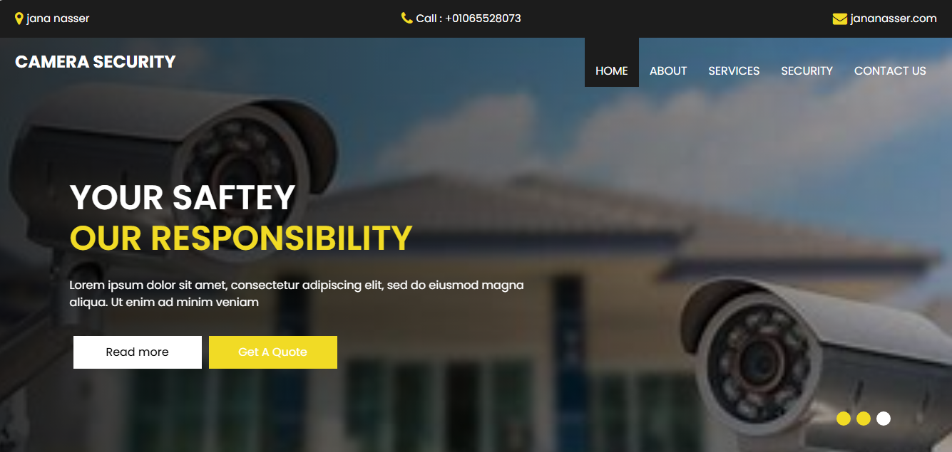

Displaying security system products and setups on a website helps companies effectively present their solutions to potential customers.

1. **Product Display**: A clear catalog of security products with detailed descriptions, specifications, and high-quality images.
2. **System Configurations**: Showcasing various security setups for homes, businesses, and custom solutions.
3. **Interactive Tools**: Offering diagrams or 3D models to demonstrate how products work together.
4. **Installation Instructions**: Providing guides or videos for DIY installation, with professional installation options.
5. **Showcase Examples**: Featuring case studies or testimonials to enhance credibility.

These elements make it easier for customers to explore and understand security solutions.

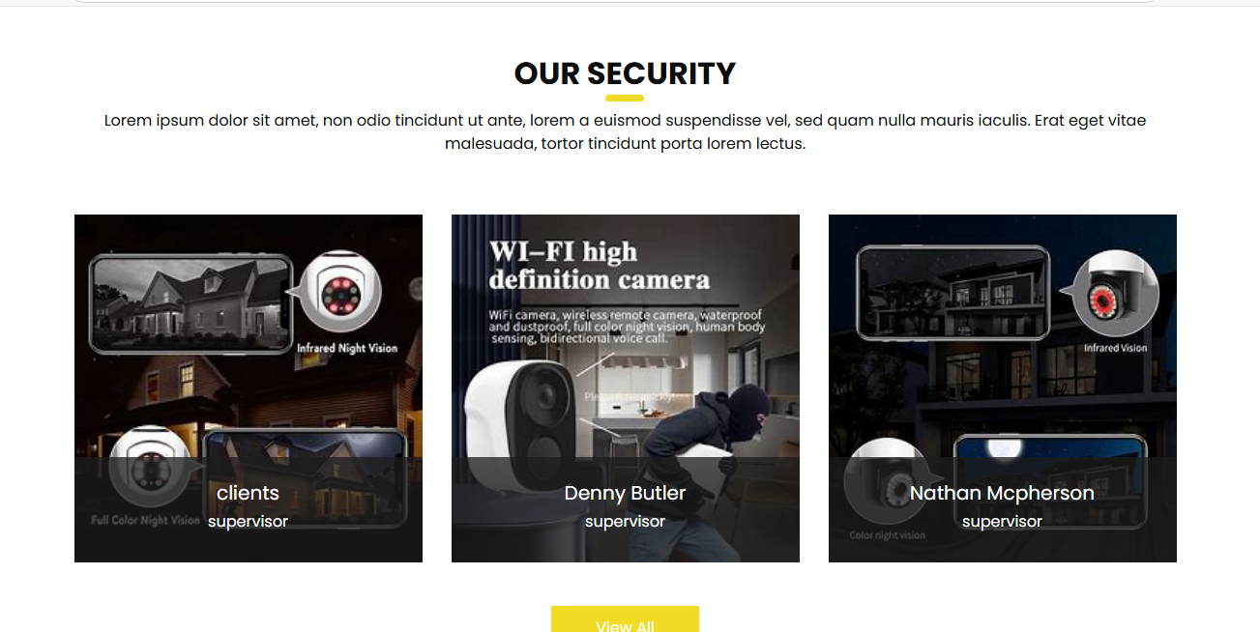

• User**-Friendly Interface**: The platform should have a simple and easy-to-navigate interface with clear options for customers to inquire about services or book them.

• Inquiry **Submission Capability**: The platform should include an inquiry form that collects information such as the customer's name, email, type of inquiry, and a detailed message. Additionally, a "live chat" feature could be added to provide instant responses.

• Flexible **Booking System**: Offer an integrated calendar that allows customers to select a date and time that suits them for booking a service. The system should include notifications to confirm or modify the booking, as well as reminders for the scheduled appointment.

• Multi**-Channel Support**: Various communication channels can be provided, such as email, SMS, or messaging apps like WhatsApp, to facilitate customer interaction.

• Service **Booking Management**: Employees should be able to manage bookings, follow up on inquiries, and provide timely responses to customer inquiries.

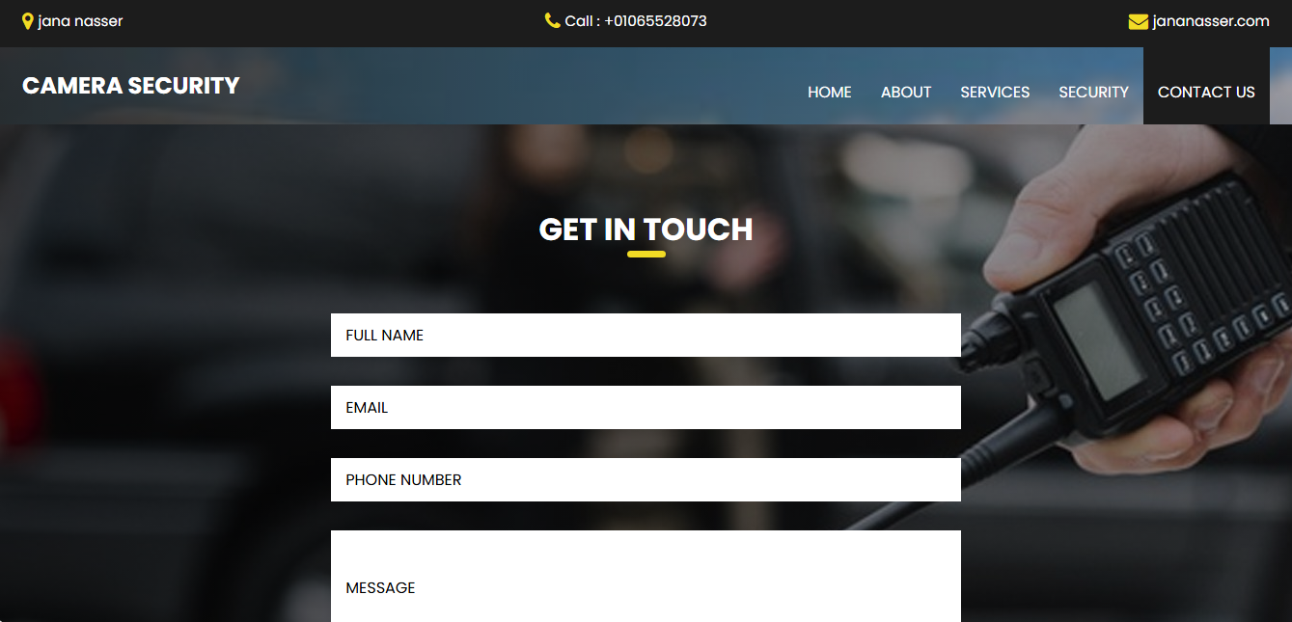

Integrating customer testimonials and case studies into your platform boosts credibility and helps new customers understand the quality of your services.

1. **Customer Testimonials**: Include real customer reviews, texts, images, or videos, and update them regularly to maintain relevance.
2. **Case Studies**: Showcase detailed examples of how your services solve customer problems, providing context and results.
3. **Integration**: Link testimonials to case studies to demonstrate the real impact of your services.
4. **Prominent Display**: Make testimonials and case studies easily accessible and visually appealing on the website.
5. **Regular Updates**: Continuously add new testimonials and case studies to reflect service improvements and build trust.

This approach helps build trust with potential clients by showcasing successful experiences.

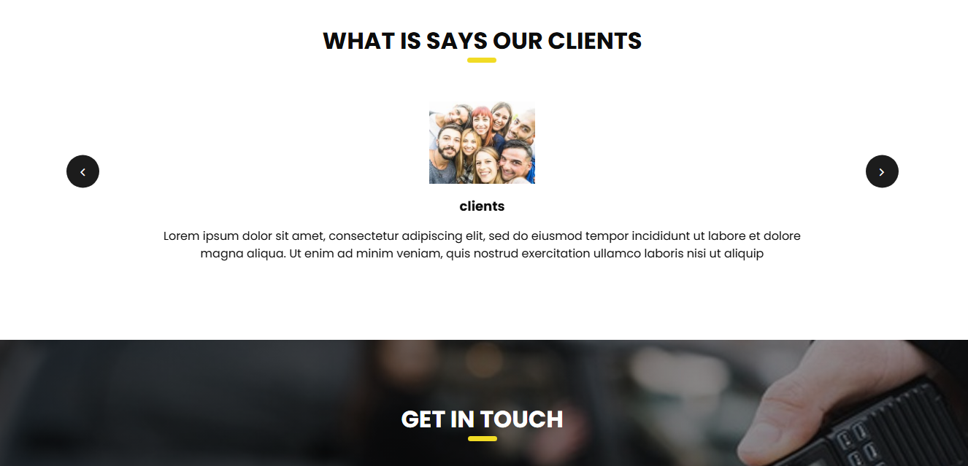

1. **Responsive Design**: Ensure the site adapts to all screen sizes (smartphones, tablets, desktops).
2. **Fast Load Speed**: Optimize images and files to improve site loading times.
3. **Simple User Experience**: Easy navigation with clear menus and buttons suitable for all devices.
4. **Cross-Platform Compatibility**: Ensure the site works seamlessly across different operating systems and browsers.
5. **Adaptable for Home and Work**: Offer features that cater to both professional and personal activities, such as quick booking or chat support.
6. **Regular Testing**: Continuously test the site on various devices and operating systems to ensure smooth functionality.

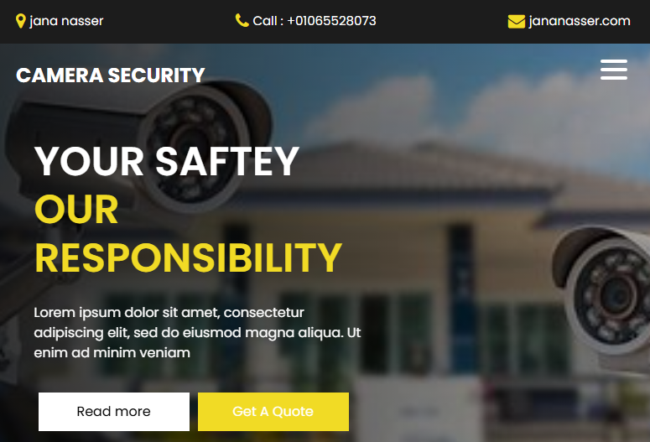

**SEO-optimized pages to improve visibility:**

1. **Keywords**: Research relevant keywords and use them naturally in titles, descriptions, and content.
2. **Titles and Meta Descriptions**: Ensure each page has a unique title and meta description that includes target keywords.
3. **High-Quality Content**: Provide valuable and relevant content, and update it regularly.
4. **Internal and External Links**: Use logical internal links and build quality backlinks to enhance authority.
5. **Page Speed and User Experience**: Optimize site speed and ensure mobile compatibility for better rankings.
6. **Image Optimization**: Use appropriately sized images with alt text that includes keywords.
7. **Clean URL Structure**: Keep URLs simple and include relevant keywords.
8. **Analytics and Tracking**: Use tools like Google Analytics and Google Search Console to monitor performance and improve SEO.

Implementing these practices will boost search engine rankings and enhance the user experience

**2-End Users’ Requirements:**

1. **Simple Navigation Menus**:  
   Make the menus clear and straightforward, with logical categories to quickly guide users to the information or services they are looking for.
2. **Visual Hierarchy**:  
   Use a hierarchical design that reflects the importance of content, with main titles being more prominent and followed by subheadings, helping users easily understand the content structure.
3. **Prominent Buttons and Links**:  
   Ensure that important buttons and links are clear and stand out, making it easy for users to interact with them. Buttons should be in a distinctive color and appropriately sized.
4. **Advanced Search**:  
   Include an advanced search feature that allows users to find content quickly, especially if the site contains a large amount of information.
5. **Responsive Design**:  
   Navigation should be easy on all devices, including smartphones and tablets. Ensure the design adapts well to all screen sizes.
6. **User-Friendly Content Organization**:  
   Organize content in an intuitive way, so visitors can easily understand how to find the information and services they need without complexity.
7. **Guidance and Notifications**:  
   Use clear, guiding notifications, such as pop-up messages or tooltips, to help users make the right decisions as they navigate.

By applying these principles, you will create smooth navigation and a comfortable user experience, which will increase customer satisfaction and encourage repeat visits.



**Easy access to product information and installation services:**

1. **Clear Product Information**: Offer detailed descriptions, images, and videos to help customers understand what they’re buying.
2. **Search and Filters**: Implement search and filter options for users to easily find products that meet their needs.
3. **Dedicated Installation Page**: Create a section with details on the installation process, costs, and booking options.
4. **Guides and Tutorials**: Provide easy-to-follow guides or videos for customers to install products themselves or with professional help.
5. **Customer Reviews**: Display reviews and ratings to build trust.
6. **Mobile-Friendly**: Ensure all information is easily accessible on mobile devices.
7. **Live Support**: Offer live chat or contact options for quick assistance.

These steps make it simple for customers to access all the information they need, enhancing their experience and satisfaction.



**Fast loading times and mobile responsiveness:**

Fast loading times and mobile responsiveness are crucial for a positive user experience. To improve load times, optimize images, minimize HTTP requests, and use caching to reduce load times. A responsive design ensures the site works seamlessly on any device, especially mobile, which should be prioritized with a mobile-first approach. Implementing Content Delivery Networks (CDNs) and minifying code can further speed up the site. Regularly monitor performance with tools like Google Page Speed Insights to maintain optimal speed and functionality.

**Secure browsing and access to contact forms:**

Secure browsing is essential to protect user data, and using HTTPS with SSL certificates ensures that all information transmitted through the site is encrypted. This builds trust with visitors, especially when they are submitting personal or payment details. To enhance security, consider implementing two-factor authentication (2FA) for areas that require additional protection. Contact forms should be easy to find, with clear labels and simple fields, so users can quickly get in touch. Ensuring the contact form is secure and user-friendly encourages visitors to reach out with confidence.

**Ability to browse services by category:**

Allowing users to browse services by category makes it easier for them to find what they need quickly. Organizing services into clear categories like "Home Security" or "Small Business Security" helps customers navigate the site more efficiently. Each category should have a well-defined description and a list of relevant services to make the browsing experience intuitive. Filters or subcategories within each section can further narrow down choices for users. This structure enhances user experience, ensuring they find the right service in just a few clicks.

**Ability to request a quote or book an installation service online:**

Offering the ability to request a quote or book an installation service online streamlines the customer experience. A simple and user-friendly form allows users to input their details, service preferences, and desired dates for booking. The process should be quick, with clear options for choosing the type of service and scheduling. Instant confirmation or follow-up notifications can ensure customers know their request has been received. This feature not only saves time but also increases convenience, making it easier for customers to access services when needed.



**Alternative**

It is assumed that the user does not like the black background because it is uncomfortable for the eye and wants to change the color to white instead of the black background.

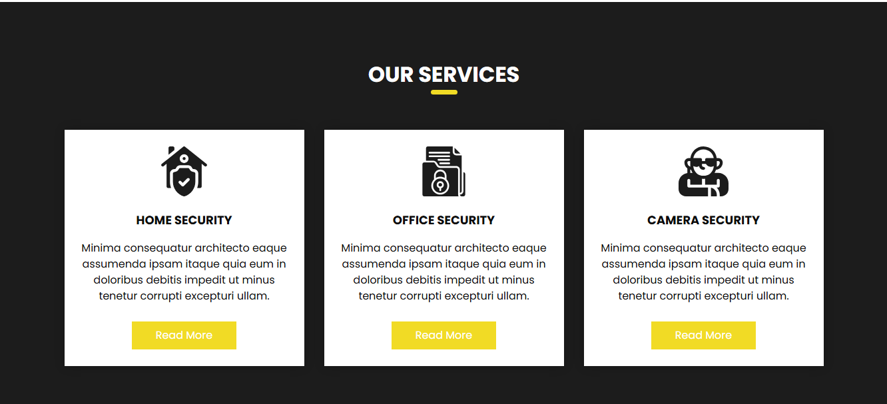حفظ الترجمة

**review and feedback**

Providing a **review and feedback** system is essential for improving services and building trust with potential customers. A dedicated section for customers to share their experiences allows them to rate services and provide comments. This helps businesses identify areas of improvement and respond to concerns quickly. Positive reviews also act as testimonials, reinforcing the credibility of the services. Encouraging regular feedback fosters a sense of customer engagement and loyalty, ensuring continuous improvement and satisfaction.

Our customers have been very impressed with the website and the experience it offers. They have expressed complete satisfaction with the design and ease of navigation, and praised the quick access to information and services. The positive feedback we've received reflects how comfortable they feel using the platform. We are happy to provide an experience that meets their needs and expectations.

Our customers were also very pleased with the color schemes and overall design of the website. They found the service to be excellent and appreciated the attention to detail in the layout. The feedback we've received highlights their satisfaction with both the aesthetics and functionality of the platform.



**conclusion**

In conclusion, a robust security system is essential for protecting both physical and digital assets, providing peace of mind to individuals and businesses alike. It involves a combination of advanced technology, proactive monitoring, and well-defined protocols to detect, prevent, and respond to potential threats. A good security system not only ensures safety but also enhances the overall customer experience by building trust and reliability. As technology continues to evolve, so too must security measures, adapting to new challenges and maintaining high standards of protection. Ultimately, investing in a comprehensive security system is crucial for safeguarding property, data, and the well-being of all stakeholders involved.